Software Design
atos
Holiday chat agent – synoptic project
Jamie Butler
2021

Contents
Purpose 2
Overview and Objectives 2
Construction 2
2
Data Storage 2
Design 3
Chat Agent Modal 3
Navbar & Feedback Container 3

Purpose

Overview and Objectives
First Holiday Ltd would like to create a chat agent, offering customers a series of questions and ultimately a set of Holiday packages based on their responses.
The chat agent will contain custom message parsing logic, detecting key words in the user’s text input, prompting a series of questions and widget functions with option-based answers.

Construction
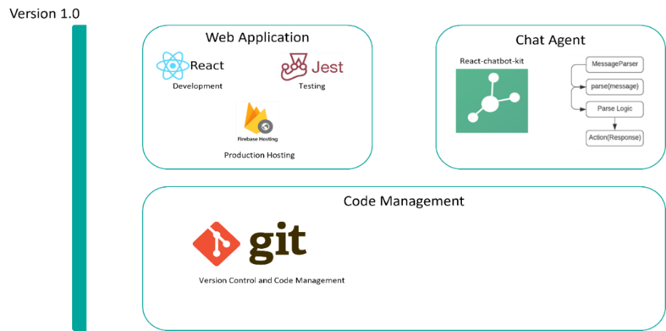
The solution will be developed as a web-based application using ReactJS as a framework. The demo production environment will be hosted using Firebase Hosting, as Firebase offers an excellent back-end-as-a-service, providing production-ready features such as authentication and Cloud functions. Predominantly written in JavaScript, the application will also utilise the React-chatbot-kit. This package offers the autonomy to create bespoke parsing logic and function-like widgets all within the chatbot container. The production version of the chatbot does conform to the design, maintaining all the key elements – in addition to some styling changes which are completely mutable for client requirements

Current technology stack as of version 1.0

Data Storage
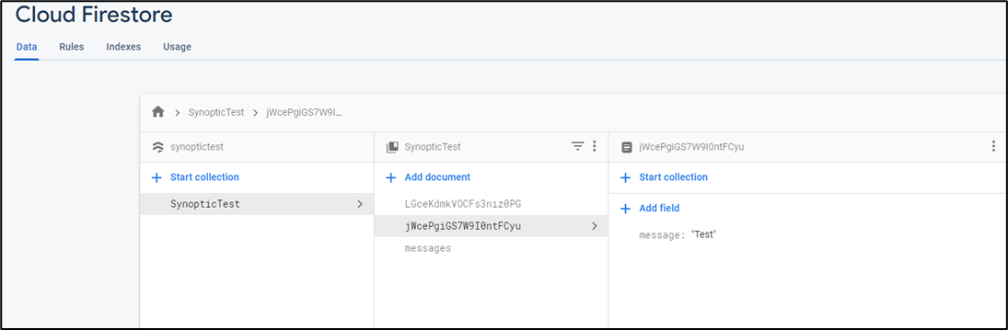
The solution will utilise a Firebase Firestore noSQL database. The main purpose for the will to house the auditing for user messages in string format. Firebase Firestore is suitable for this solution as the current iteration of the product produces key-pair data in a predominantly read-only format. Currently, only the messages from the user are audited, this allows First Holiday Ltd to analyse the questions asked, opening the possibility to adapt the agents script and parsing logic.

Design

Chat Agent Modal
The Chat Agent Modal will be accessible using the Modal toggle buttons in the top right of the page of the Home Page Route, containing a Header section, Chat Agent container, message containers, messages and finally the message input text field. The Chat Agent container will be in the bottom right of the screen to avoid collision with page content. Designs are shown below.
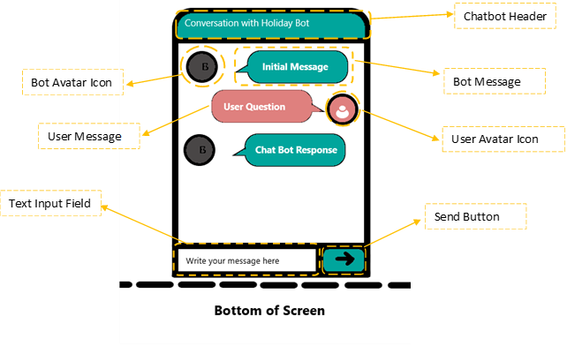

Navbar & Feedback Container
The Navbar is the navigational component in the web-app’s user interface. Containing the company’s logo, in addition to links navigating the rest of the website using the react-router-dom. This component will be rendered indefinitely, regardless of the route that is actively rendered, ensuring that other pages can be navigated to at any given time. Moreover, the feedback container will only render once after the Chat Agent has been closed for the first time.

Route Link
NavBar Title
Route Link

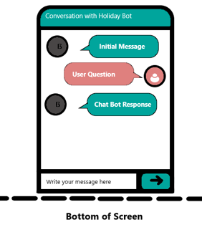
Feedback Box

